Welcome!
Date
Name
Spouse
Address
City
State Zip _________
Email

Please Contact By
❑ Card  Phone  Visit

Telephone Best Time to Call
Home ______________
Work ______________

Guest: First Time Second Time
Are you a church member: yes no
Church
City, State

Circle Appropriate Age/Grade Group(s)
Preschool: Ages: B-1 2-3 4-5
Children: Grades: K 1 2 3 4 5 6
Youth: Grades: 7 8 9 10 11 12
Adults: Ages:18-29 30s 40s 50s 60s+

How did you learn about our church?
Newspaper Friend Yellow Pages Mail
Other

I am a guest of:

New in the Community? Yes No
Names & ages of children at home

Weekly Service & Activity Schedule

Dec 24, 2017

9:45 a.m. Sunday School
11:00 a.m. Worship Service
No Evening Service

Week of Dec 24, 2017
Wednesday 6:30 pm……………..……….Meal/Bible Study
Friday 6:30 pm……………….…………..Men’s 42 Night

December
28…………………………………………….Adult Fellowship
31……………………………….New Year’s Eve Watch Party
January
New Commandment Kids will not meet for the month of January
14………………………….………………..Lord’s Supper
14………………………………………Business Meeting

Don’t forget about the New Year’s Eve Watch Party!
Bring a finger food or snack to share.
There will be 42 and lots of games and fellowship as we ring in the New Year.
We usually start around 6, but show up anytime!



Week of Prayer for International Missions Dec 3-17

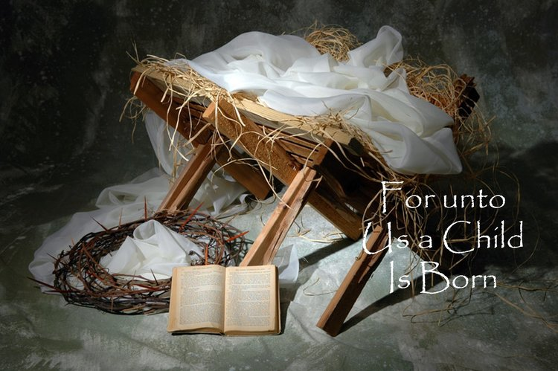

Knobbs Springs Baptist Church

Dec 24, 2017

Church Information:

KnobbsSpringsBC.com KnobbsSpringsBaptist@gmail.com

1662 CR 305, McDade, Texas 78650 512-273-2743

David Atwood, Pastor Cell 512-470-5098

Patti Radford, Office Manager Cell 512-968-7821

